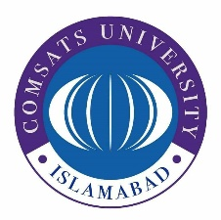
COMSATS University Islamabad

HUM111 Pakistan Studies
Second Sessional Examinations

SP21 Hybrid Course

Time: 1 Hour Total Marks: 30

Student Name: _ Registration Number: _ Campus: Date: Moderator Name:

Instructions to Students

- Write your Name, Registration Number, Campus, Date and Moderator’s Name.
- Mobile phone, digital diaries or any other digital storage medium is not allowed.
- Type your answers on the same document provided as question paper.
- Submit the answer sheet via CU Online Console in the given time. No submissions are allowed via email.
- Attempt all questions.

Declaration: It is here by informed to all examinee that use of unfair means as defined by rules and regulations is considered as an academic offense of highest nature there is. All examinees found guilty shall be dealt with in accordance to the statutory rules pertaining to student conduct, discipline and examination. The University’s decision in all such matters shall be the final binding on all parties.

For Faculty Use Only
Questions | Q. 1 | Q. 2 | Q. 3 | Q. 4 | Q. 5 | Q. 6 | Total

Section A (Short Questions 10 Marks)
Question 1 (5 marks, CLO2-A3)
Discuss how natural calamities and various plant diseases are affecting the agriculture sector of Pakistan?
Question 2(5 marks, CLO3-A1)
Briefly explain key determinants of foreign policy of Pakistan?

Section B (Long Questions 20 Marks)
Question 3 (10marks, CLO1-A1)
Discuss what were the constitutional issues faced while drafting the first constitution of the country.
Question 4 (10 marks, CLO1-A1)
Write a detail note on the salient features of Constitution of 1962.

Good Luck

